Terraform - 01

1). Install Terraform on your PC
Lets Install on Mac
First we need to have homebrew installed on our Mac use command

/bin/bash -c "$(curl -fsSL https://raw.githubusercontent.com/Homebrew/install/HEAD/install.sh)"
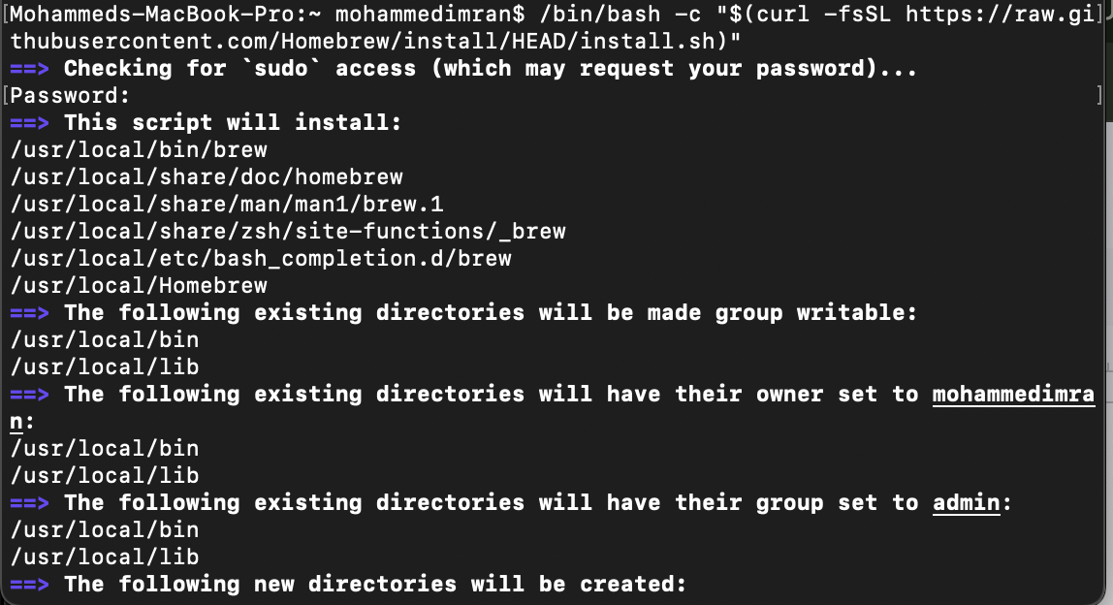
Installation Successfull and we check if the homebrew has been installed on not using version
brew –version
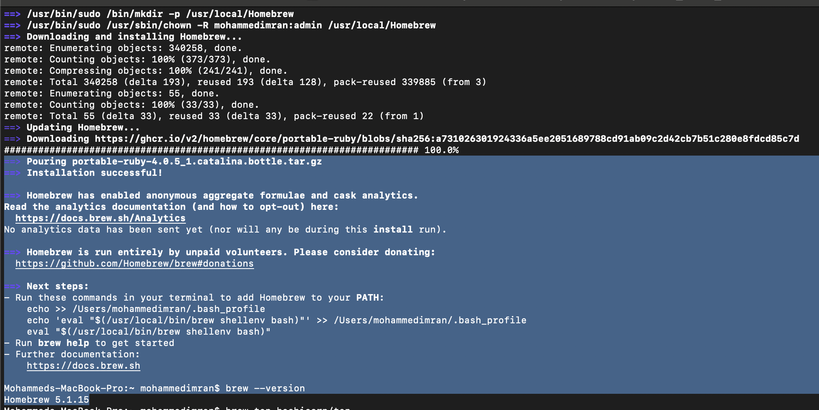
brew tap hashicorp/tap
brew install hashicorp/tap/terraform
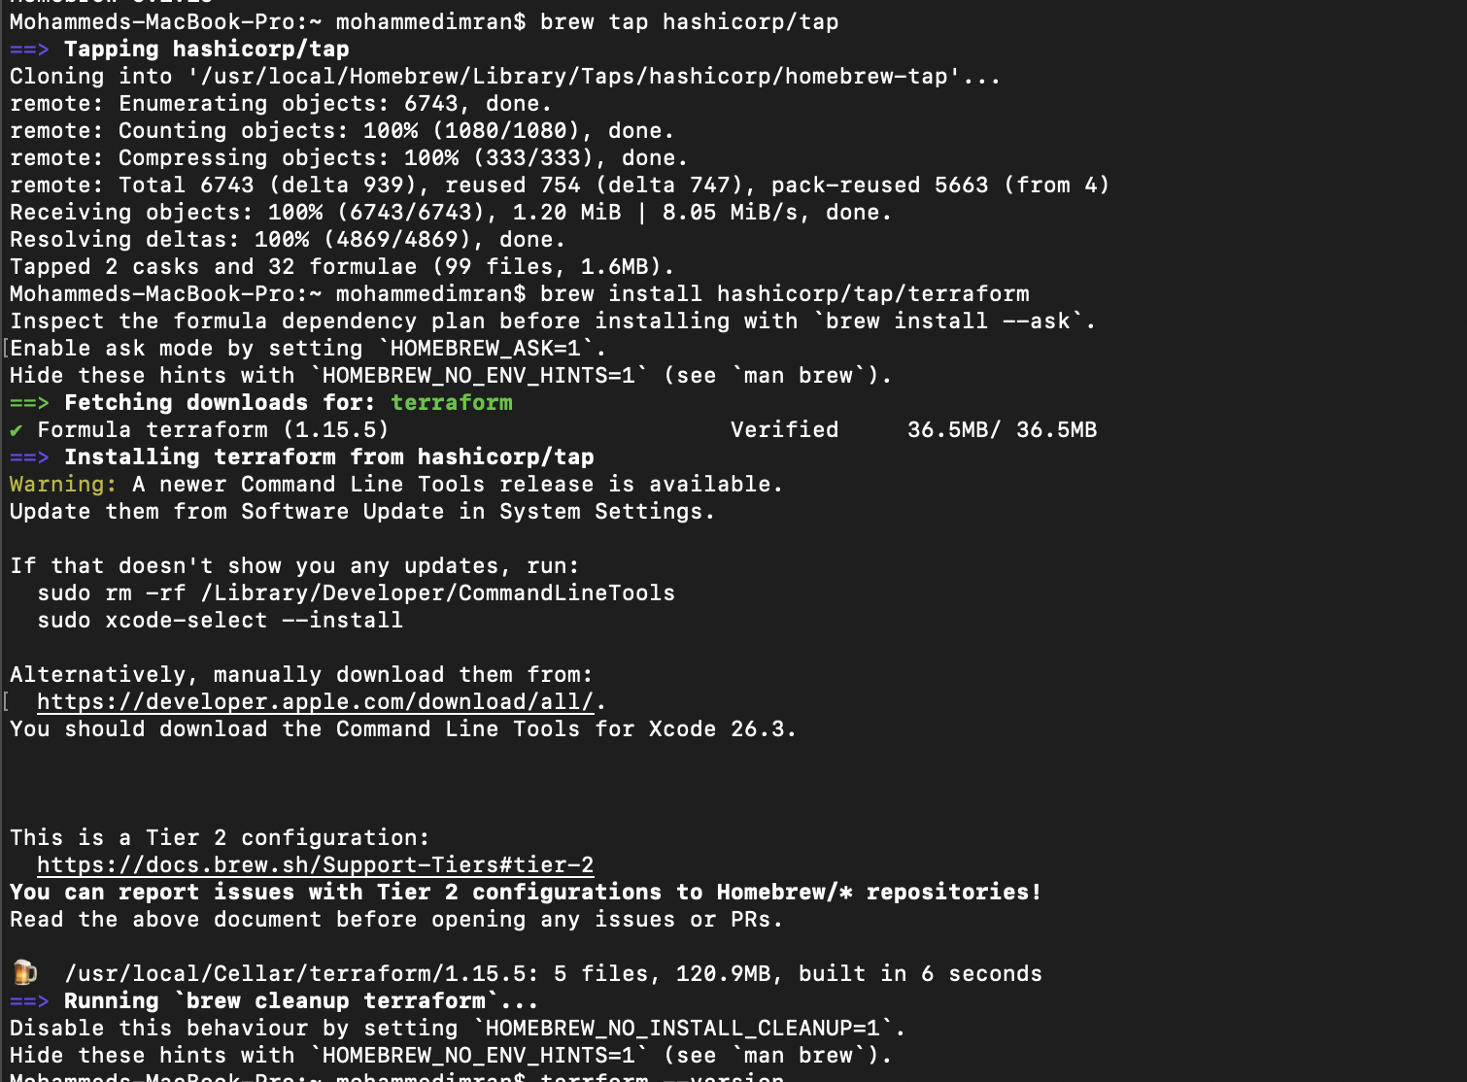
terraform –version
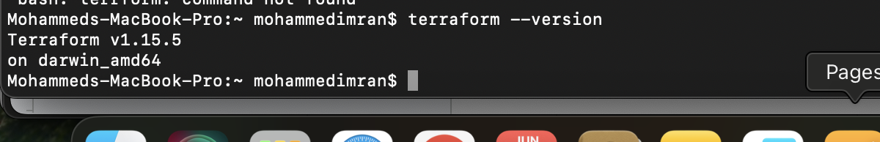

2). Execute all the templates shown in the video.
Installing Hashi Corp terraform on VS Code by going to extensions on terraform. This is a one time thing
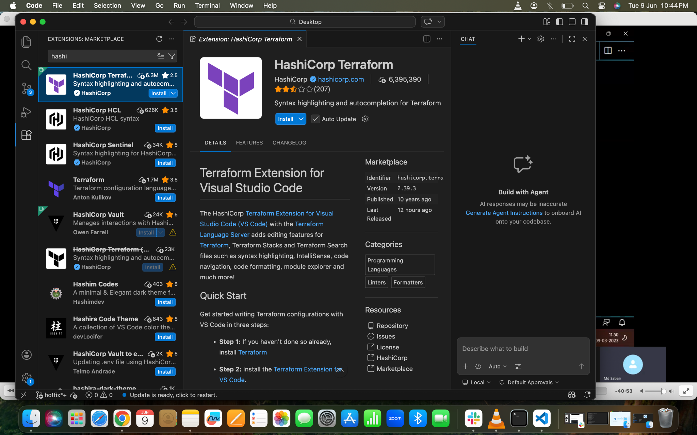
By installing the plugin it will be very easy for us to set the syntax or format of the template or configuration file.

Now lets create a main.tf file
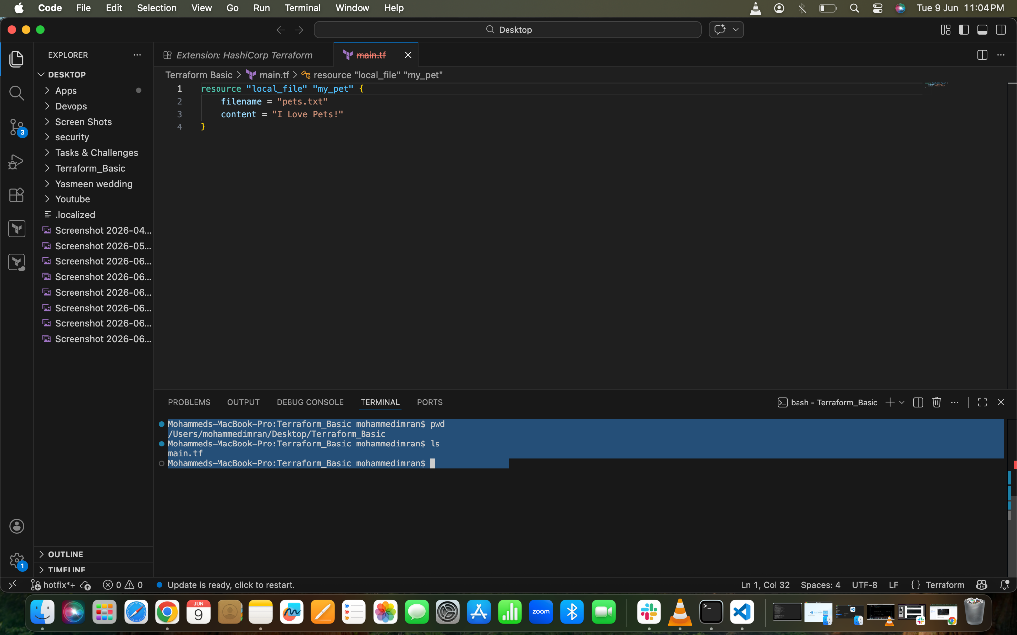
Here in the above pic you can see the terminal, there we can see the new file created in the folder we created

terraform init ⇒ to initialize our repository. It will download all the dependencies
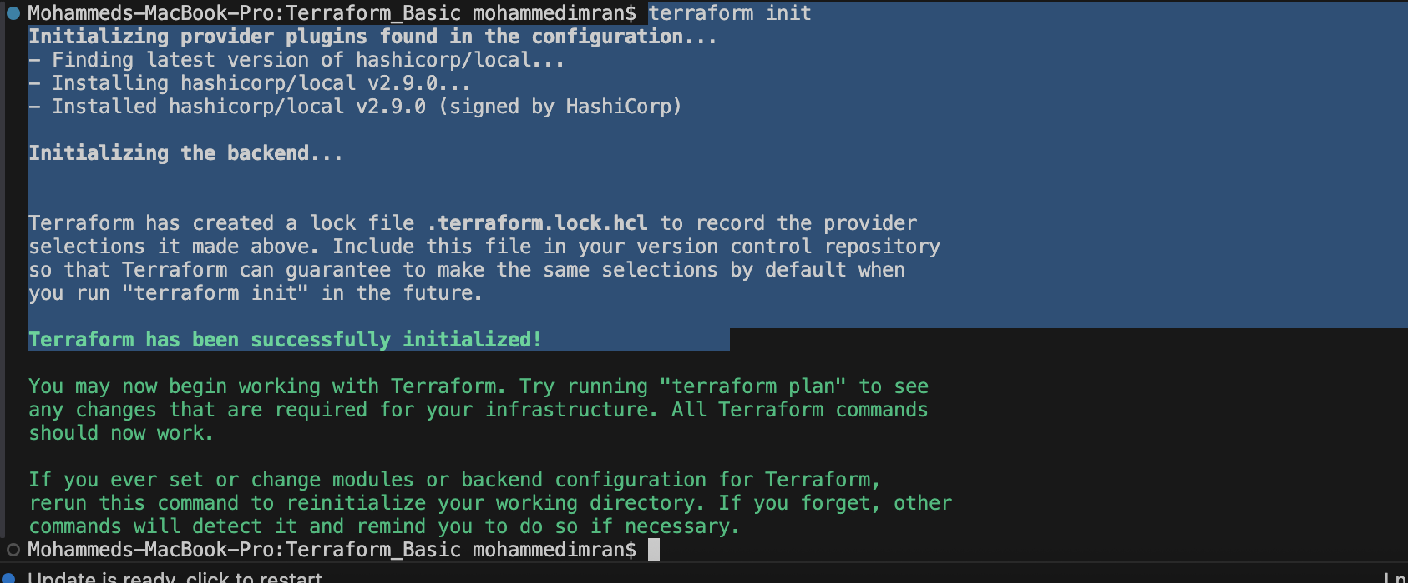

terraform plan ⇒ Dry Run⇒ It will only check how the change will be implemented or executed on the target host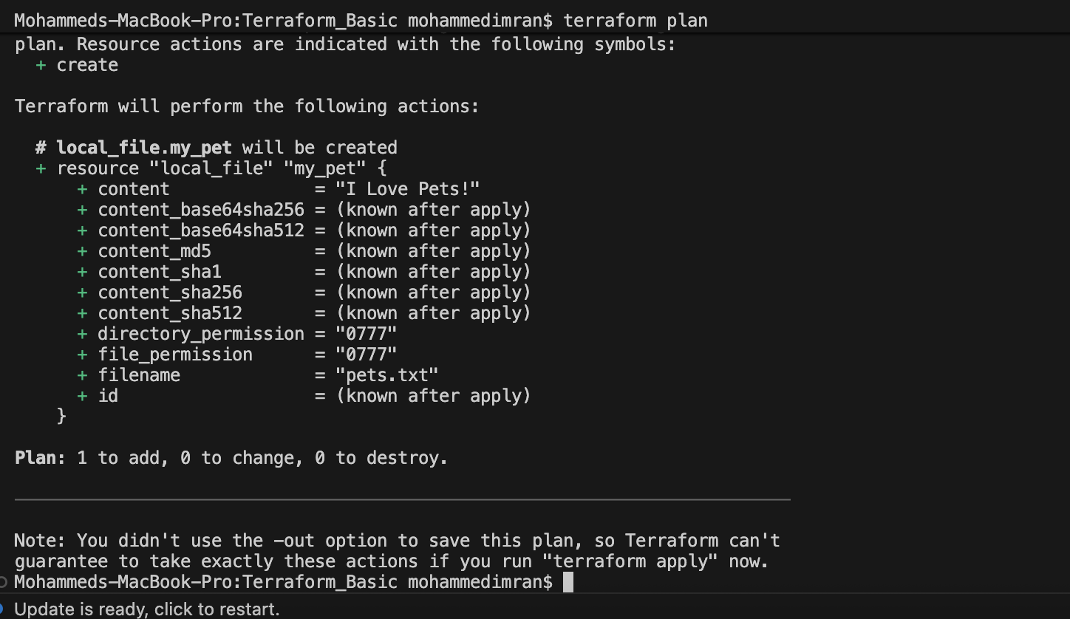

terraform apply ⇒ it will helps us to execute the template
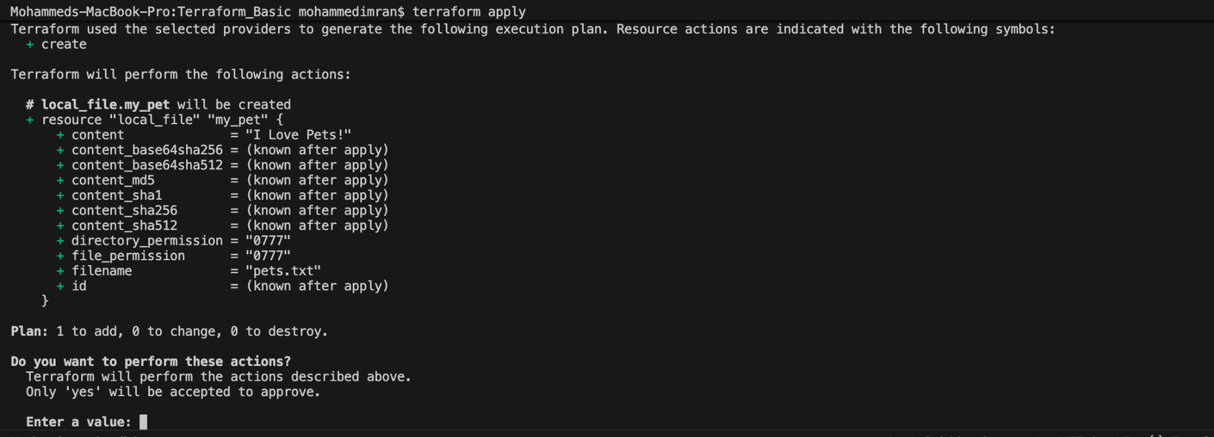
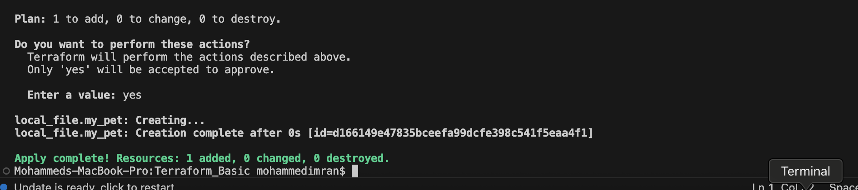

pets.txt file ahas been created
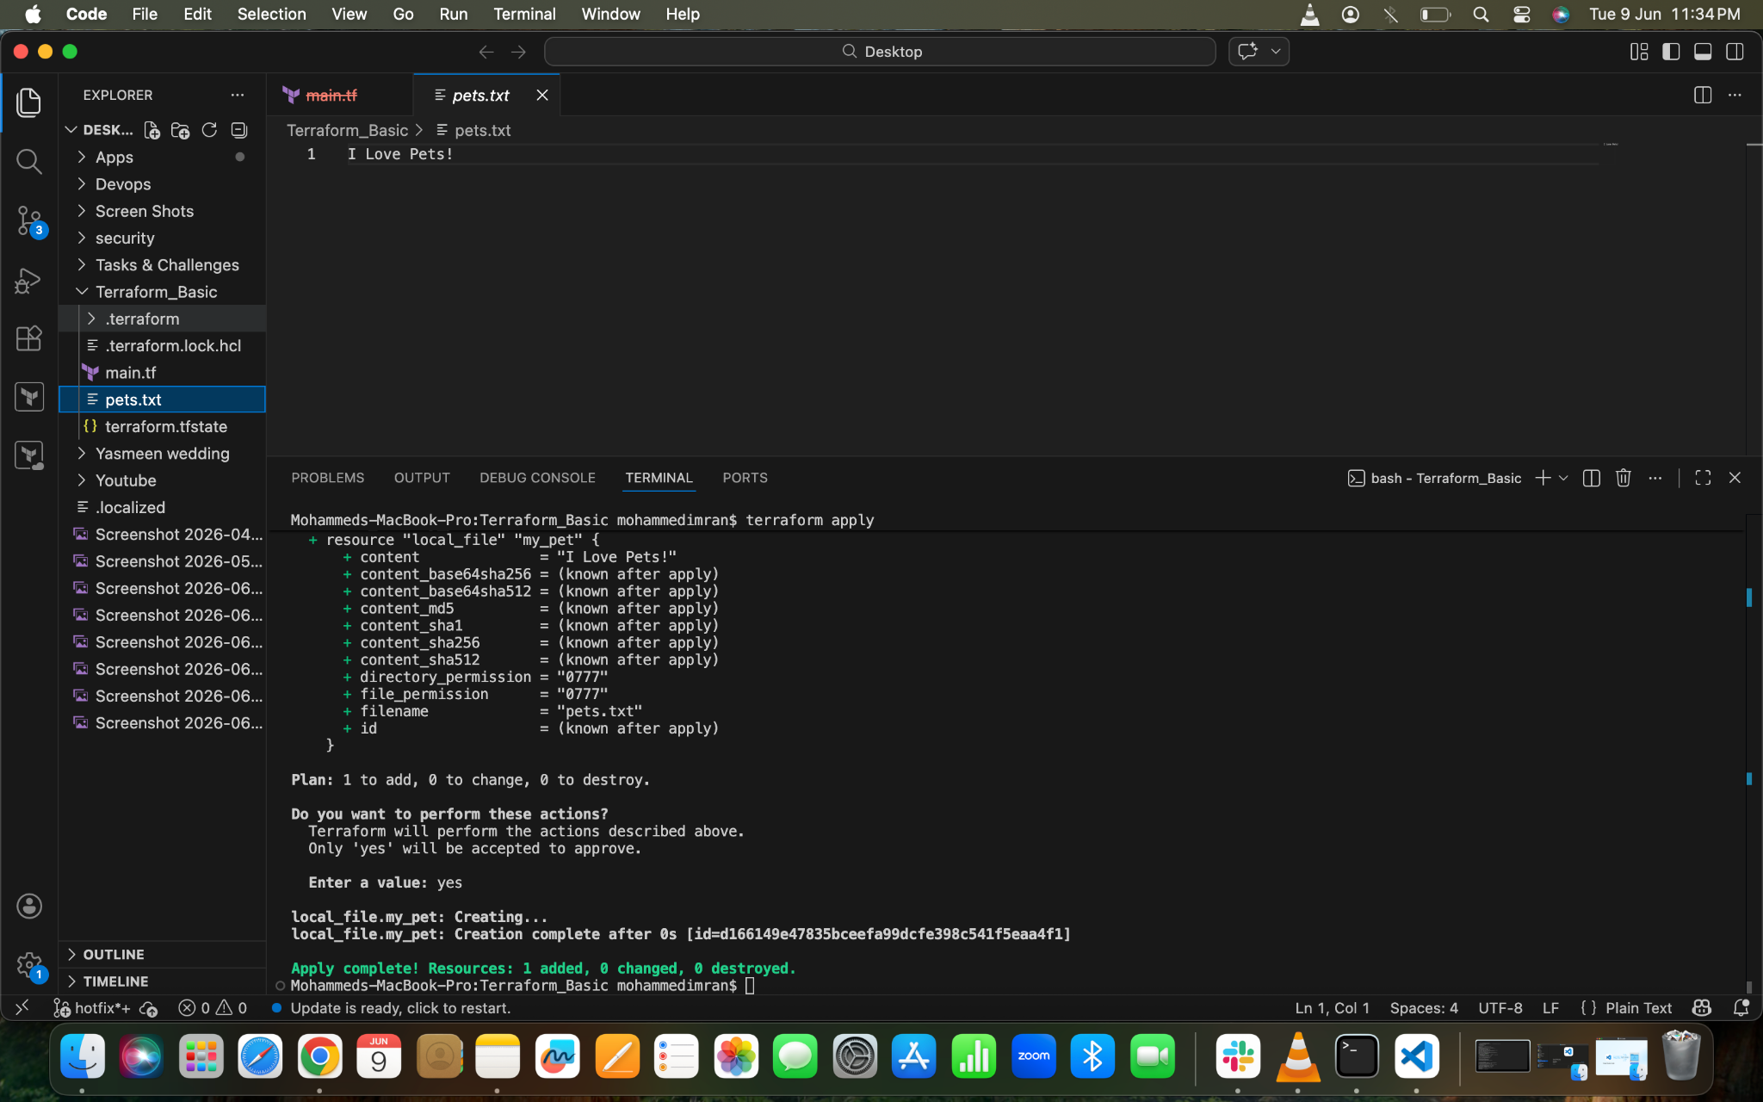
To change the content
Changed the content in file
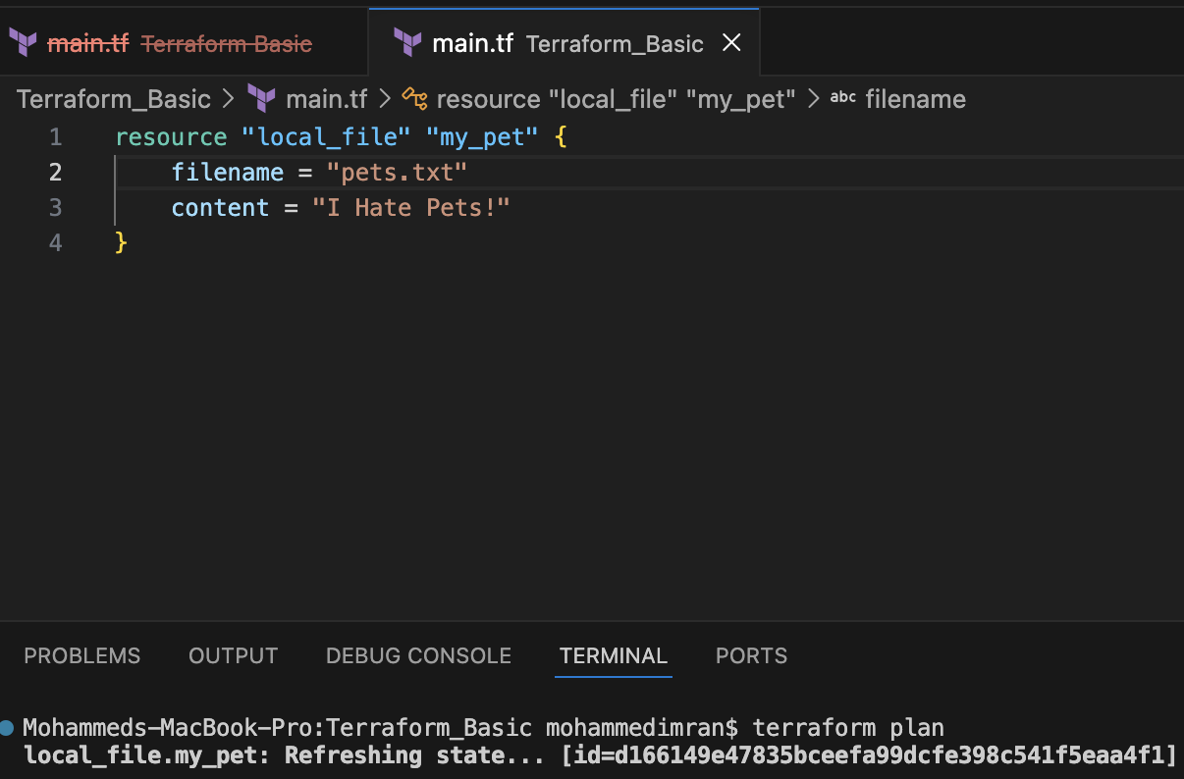
Used terraform plan we can what changes and implementation will happen

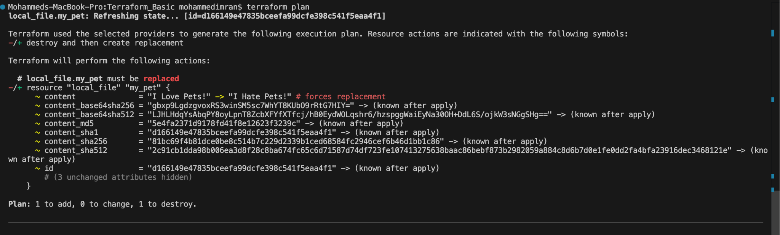
terraform apply
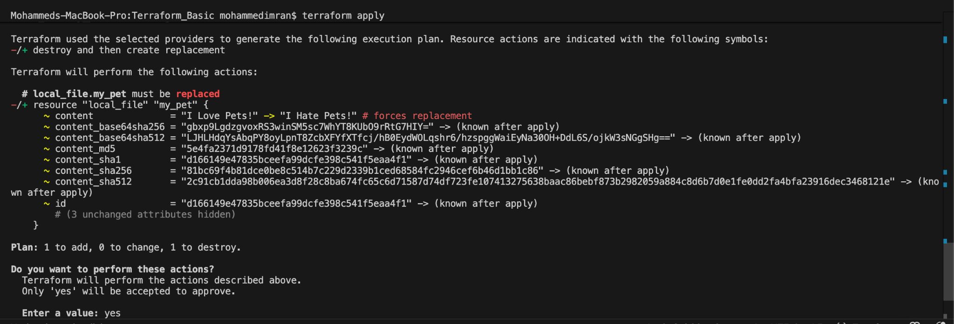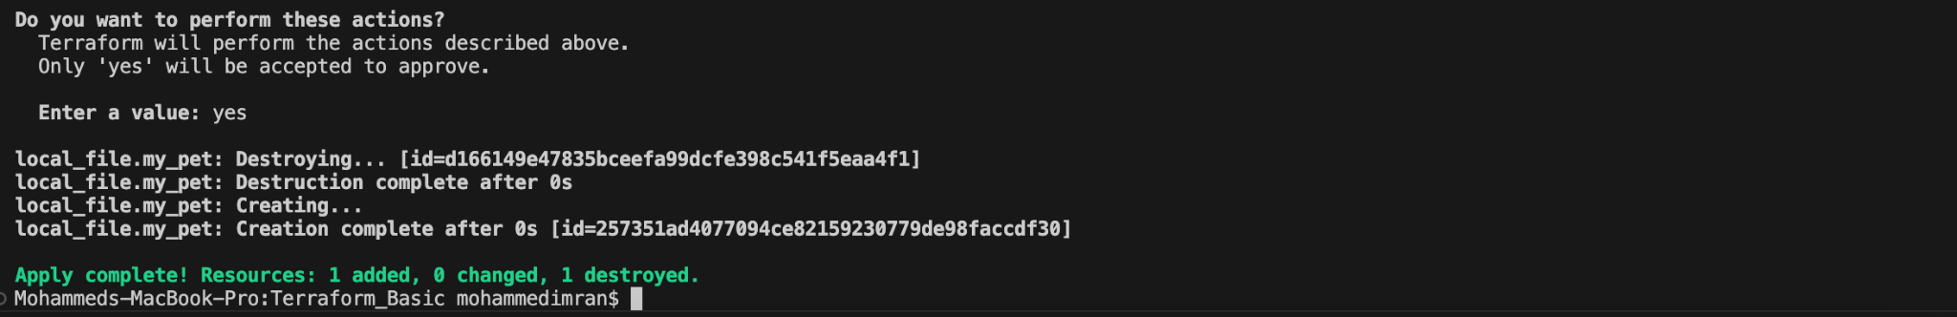
Lets check in the folder
It has been changed to to the provided content we gave
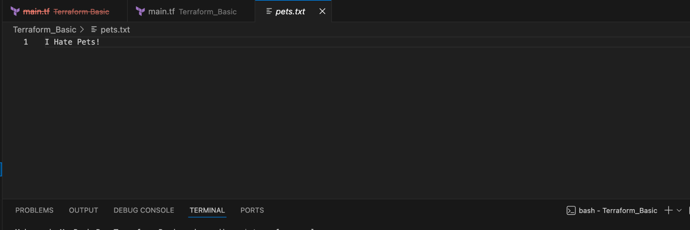

terraform destroy ⇒ to delete whatever we created
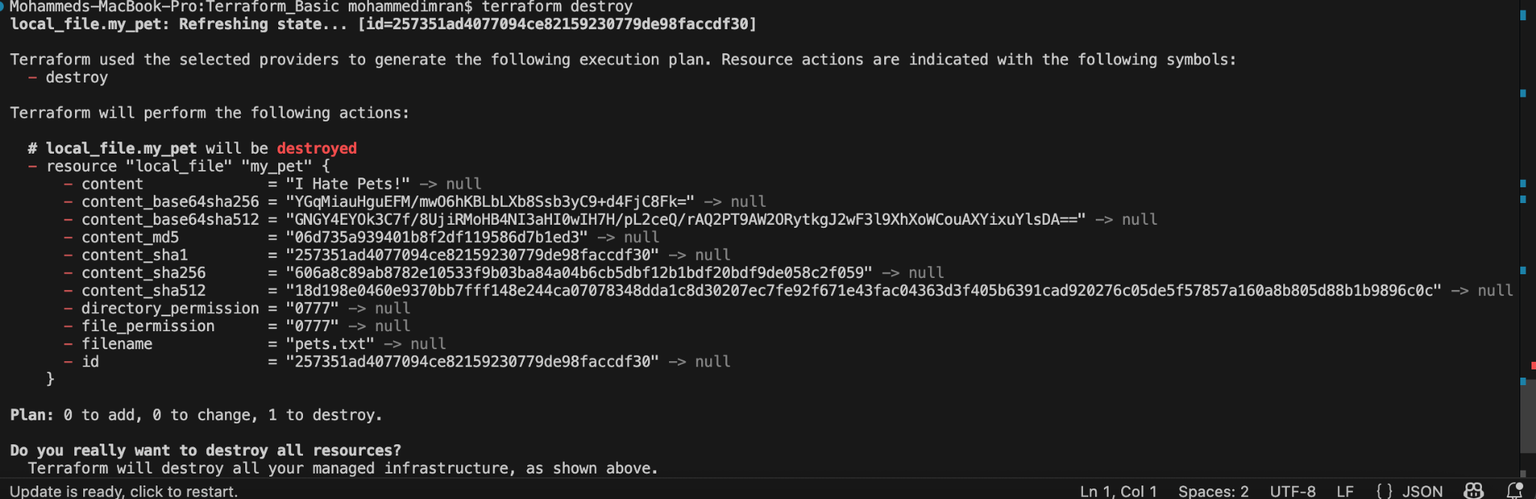
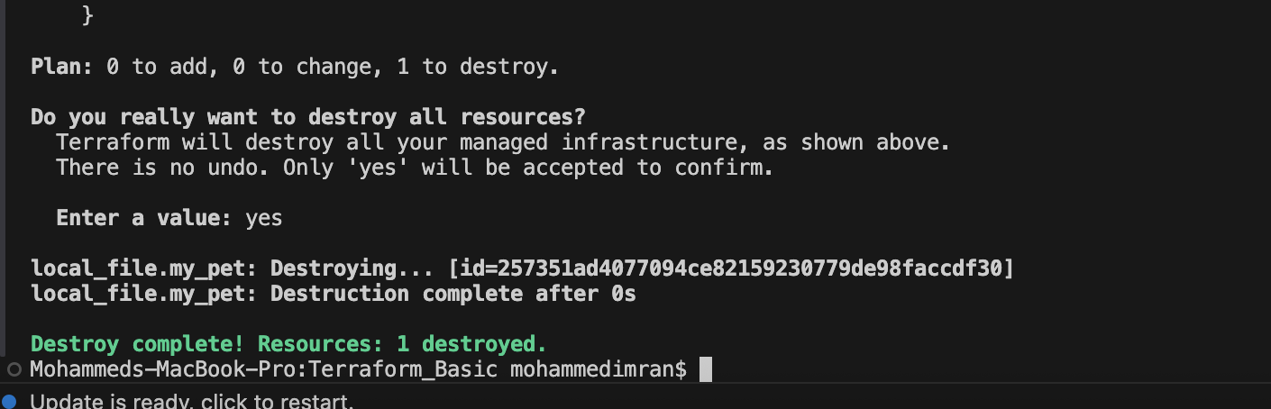
terraform fmt ⇒ it will help us to organize our syntax
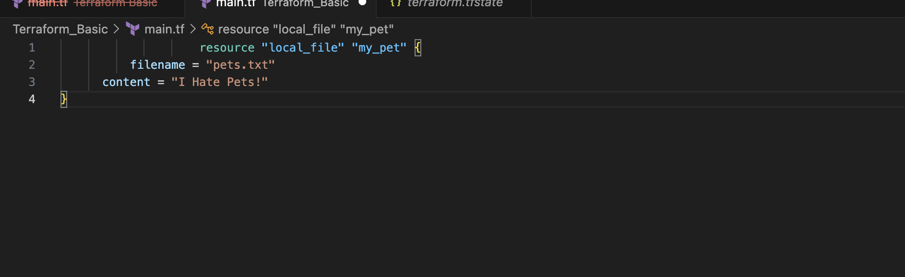
Now lets use terraform fmt and see what happens
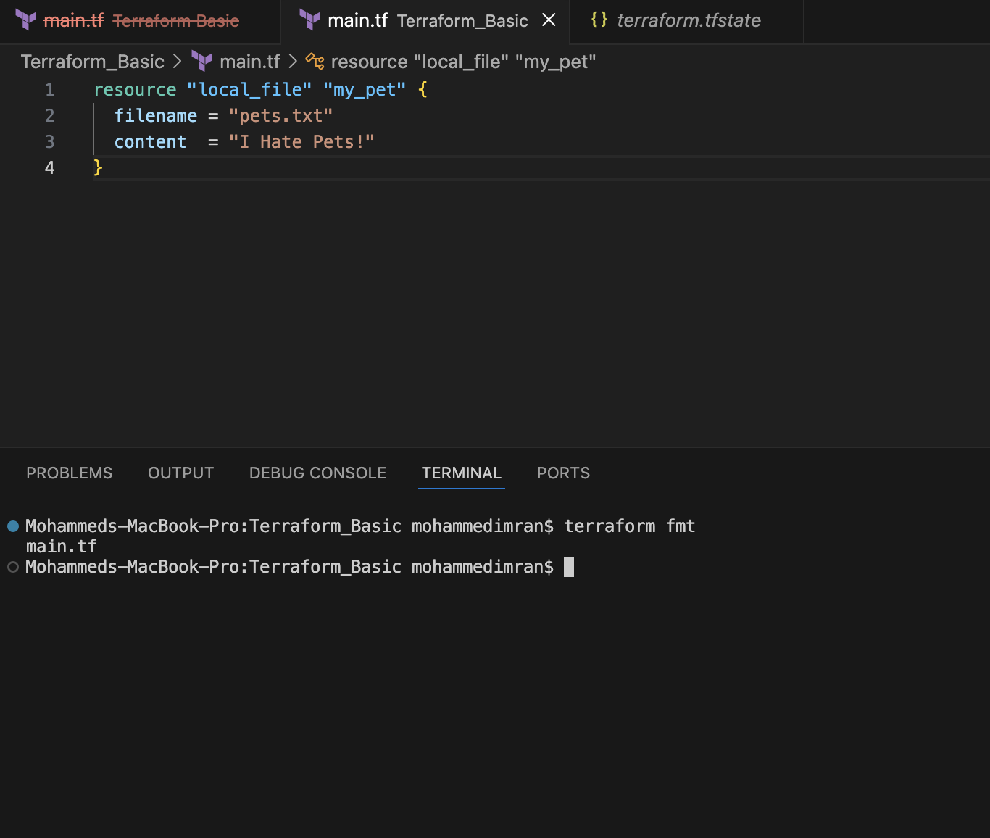

3). Note down below points, Terraform Init Terraform Plan Terraform Apply Terraform Provider.

Terraform init

Purpose:
Initializes the Terraform working directory.
Downloads required provider plugins.
Configures the backend for state storage.
Downloads referenced modules.

When to Use:
Before running any Terraform commands in a new project.
After adding or changing providers/modules.

Terraform plan

Purpose:

Creates an execution plan.
Shows what resources will be created, modified, or destroyed.
Does not make any actual changes.

When to Use:

Before applying changes to review the impact.

Terraform apply

Purpose:

Executes the changes defined in the Terraform configuration.
Creates, updates, or deletes infrastructure resources.
Updates the Terraform state file.

When to Use:

After reviewing the execution plan.

Terraform provider : It is a complete package of api calls to communicate with our
resources
Acts as the bridge between Terraform and the target infrastructure platform.

4). Integrate a sample Terraform template in Jenkins.

In Jenkins ⇒Workspace⇒terraform-jenkins⇒vi main.tf
resource "local_file" "my_pet" {
filename = "pets.txt"
content = "I Hate Pets!"
}

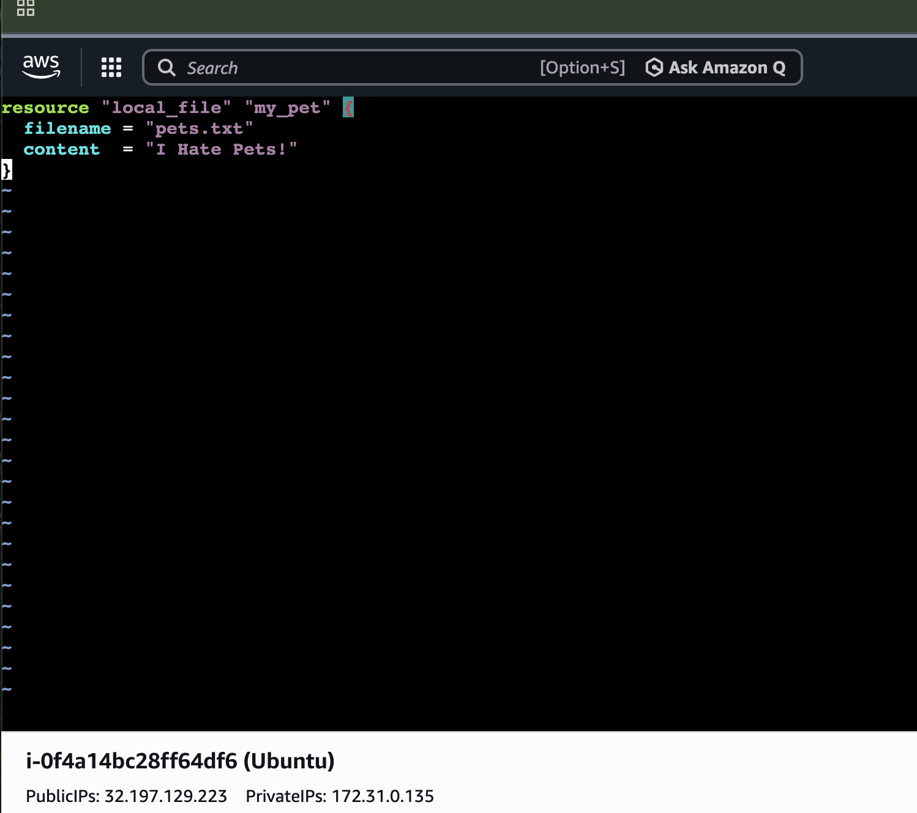

Lets Create a New job by using pipeline
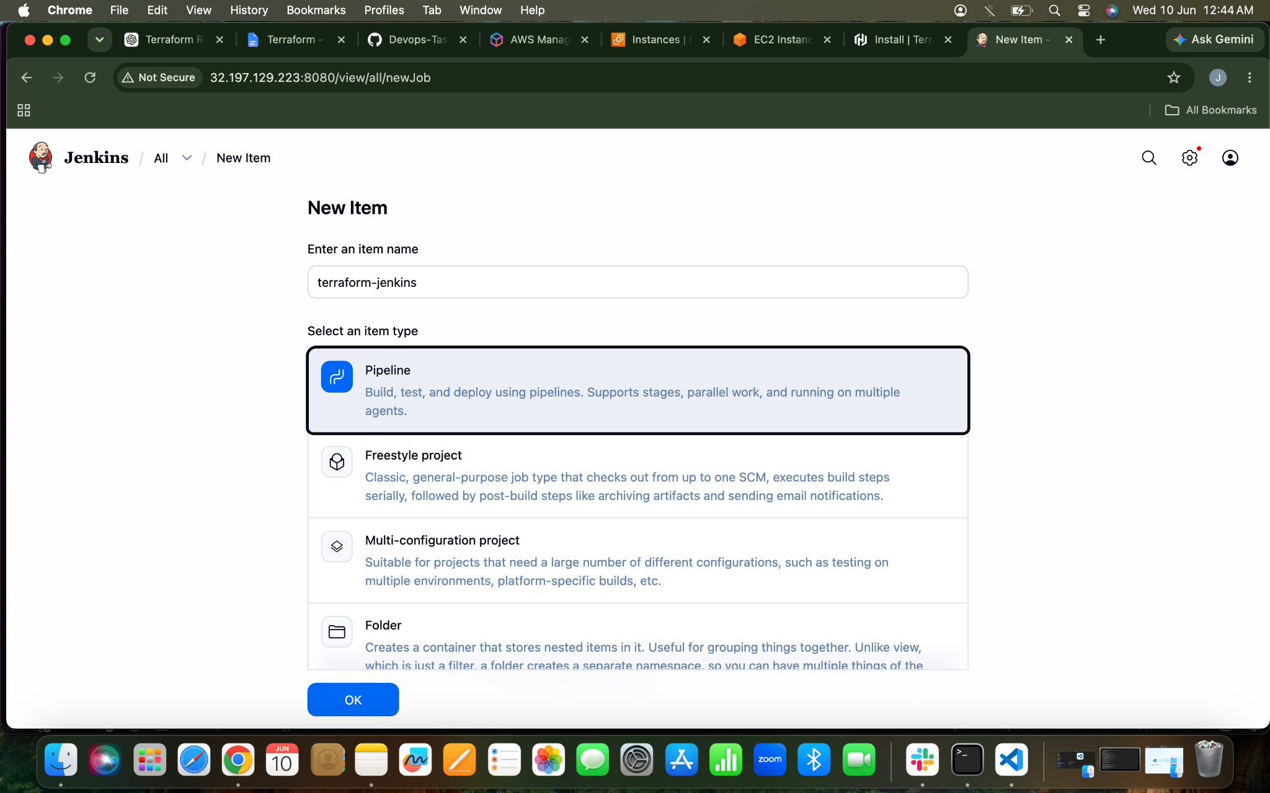
SCRIPT

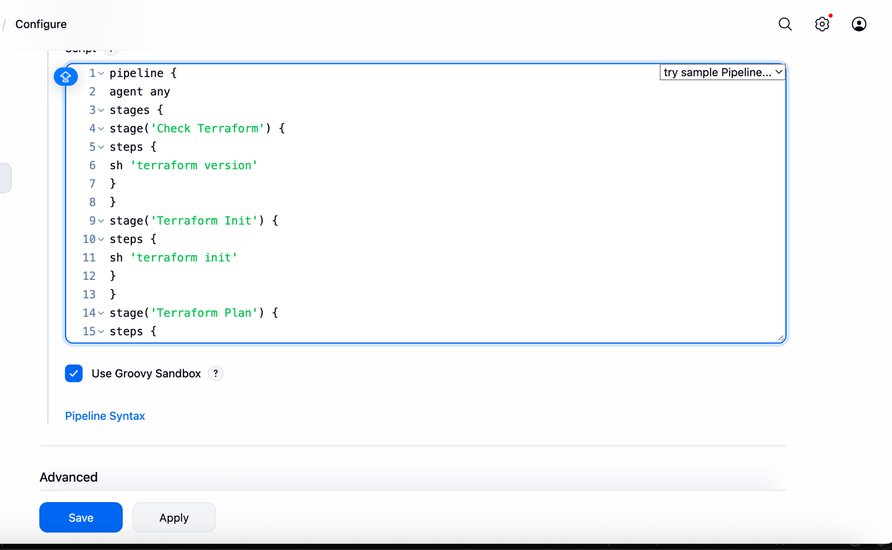

The build ran successfully
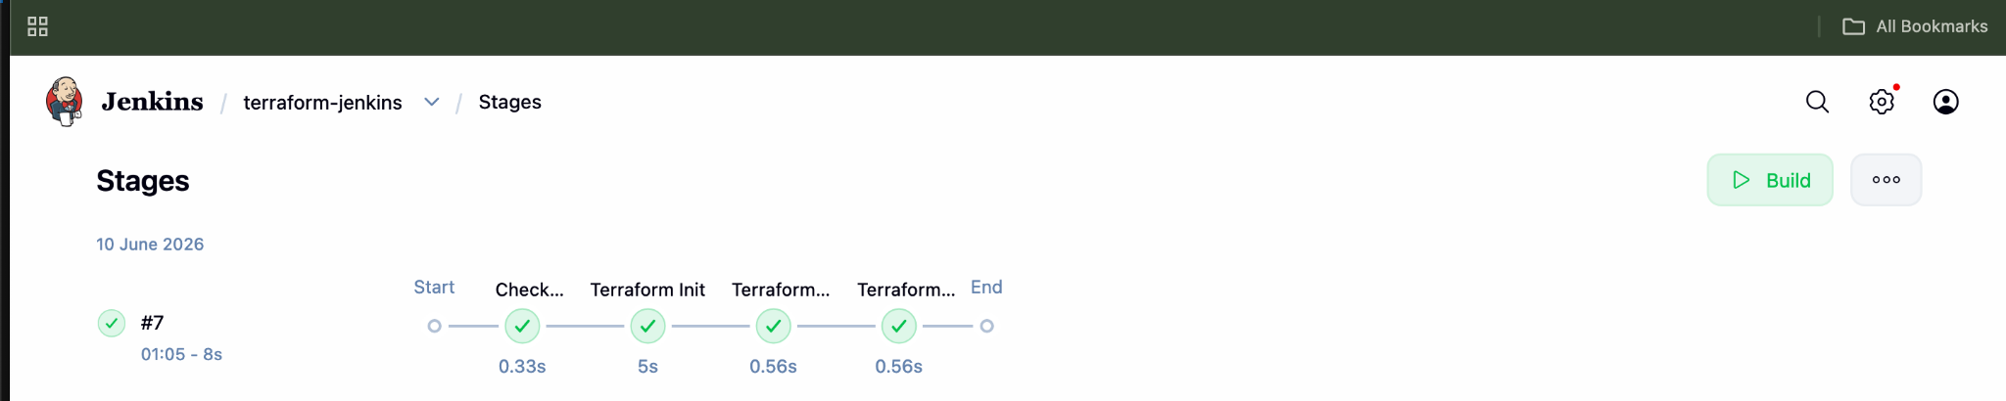
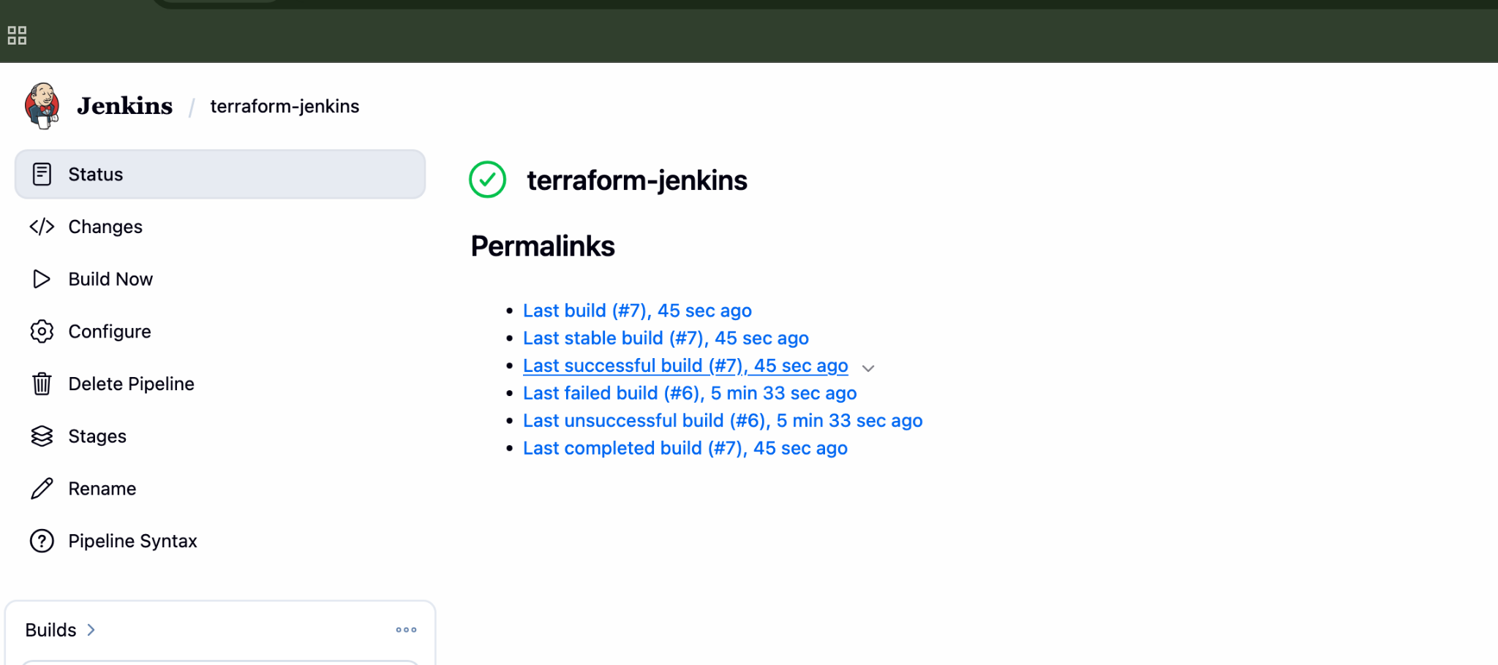
Console OutPut
